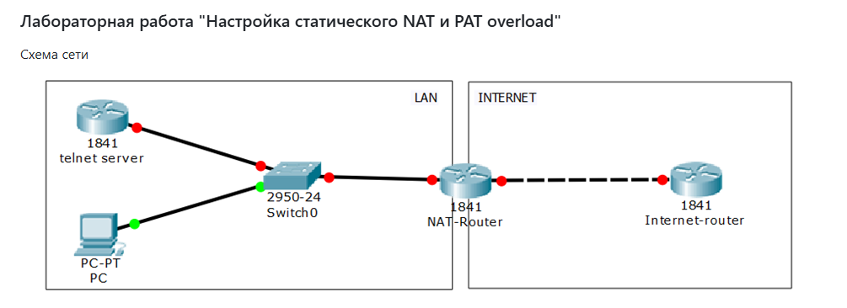

Настройки оборудования:

* 1841 telnet server  
  loopback0 10.10.10.10/32  
  Fastethernet0/0 192.168.1.10/24  
  ip route 0.0.0.0 0.0.0.0 192.168.1.1
* PC  
  Fastethernet0 192.168.1.11/24  
  ip route 0.0.0.0 0.0.0.0 192.168.1.1
* NAT-Router  
  Fastethernet0/0 192.168.1.1/24  
  Fastethernet0/1 8.8.8.1/24
* Internet-router  
  Fastethernet0/0 8.8.8.8/24

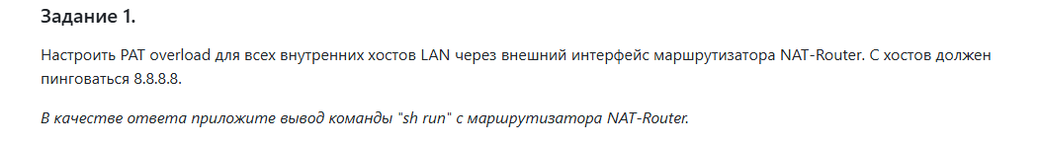

hostname NAT-Router

!

interface FastEthernet0/0

ip address 192.168.1.1 255.255.255.0

ip nat inside

no shutdown

!

interface FastEthernet0/1

ip address 8.8.8.1 255.255.255.0

ip nat outside

no shutdown

!

ip nat inside source list 1 interface FastEthernet0/1 overload

!

access-list 1 permit 192.168.1.0 0.0.0.255

!

end

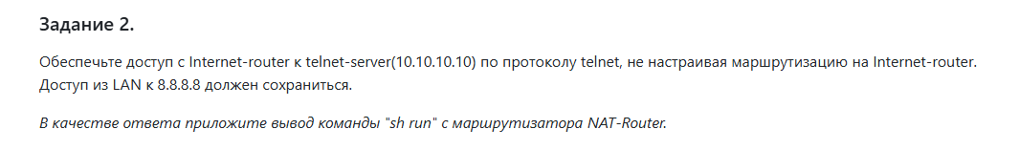

hostname NAT-Router

!

interface FastEthernet0/0

ip address 192.168.1.1 255.255.255.0

ip nat inside

no shutdown

!

interface FastEthernet0/1

ip address 8.8.8.1 255.255.255.0

ip nat outside

no shutdown

!

! NAT Overload для LAN

ip nat inside source list 1 interface FastEthernet0/1 overload

!

! Статический NAT для Telnet (TCP 23 сервер 10.10.10.10)

ip nat inside source static tcp 10.10.10.10 23 8.8.8.1 23

!

access-list 1 permit 192.168.1.0 0.0.0.255

!

**ip route 10.10.10.0 255.255.255.0 192.168.1.2**

!

end